Deploying a Web Application
[application from your desktop to the web in a matter of minutes]

Contents
Deploying a Web Application 1
Download a sample application: [I am using a ubuntu linux machine to download the code] 3
Creating a DynamoDB Table 4
Creating an SNS Topic 5
Deploying with Elastic Beanstalk 6
Elastic Beanstalk 7
Recent Events 10
Changing an Environment Variable 12
Troubleshooting with Logs 14

A.N. ANIL KUMAR

This guide provides a tutorial on deploying a web application with Amazon Web Services (AWS). Using AWS, you can develop applications quickly and then deploy them to a cloud environment that scales on demand. And with several AWS deployment services to choose from, you can create a deployment solution that gives you the right mix of automation and control.

Many of the concepts covered in this guide apply to the other AWS deployment services too. If you’re currently running a web application on an on-premises server and you’re thinking about migrating to the cloud, this guide is a great place to start. By deploying a simple but fully functional web app, you'll learn the basics of working with an AWS
deployment service.
The example app is built with Node.js, though you don't need any experience with Node to complete this
tutorial.
{Node.js is a platform built on Chrome's JavaScript runtime for easily building fast, scalable network applications. Node.js uses an event-driven, non-blocking I/O model that makes it lightweight and efficient, perfect for data-intensive real-time applications that run across distributed devices.}

Our app stores user information in an Amazon DynamoDB table
We’ll use AWS Elastic Beanstalk to deploy our application.

Send notification(s) with Amazon Simple Notification Service.
Also IAM to create a user Policy

Know your Application tools:

AWS Elastic Beanstalk
AWS Elastic Beanstalk is a high-level deployment tool that helps you get an application from your desktop to the web in a matter of minutes. Elastic Beanstalk supports applications developed in Java, PHP, .NET, Node.js, Python, and Ruby, as well as different container types for each language.

A container defines the infrastructure and software stack to be used for a given environment. When you deploy your app, Elastic Beanstalk provisions one or more Amazon EC2 instances, among other resources.The software stack running on EC2 is dependent on the container type. For example, Elastic Beanstalk supports two container types for Node.js: a 32-bit Amazon Linux image and a 64-bit Amazon Linux image, each running a software stack tailored to hosting a Node.js application.

Amazon DynamoDB :
Our application needs to store the contact information that users submit. To do so, we'll use Amazon DynamoDB, a NoSQL database service. DynamoDB is a schemaless database, so you need to specify only a primary key attribute. For our app, we'll use an email field as a key.

Amazon Simple Notification Service
We want to be notified when customers submit a form, so we'll use Amazon Simple Notification Service. Amazon SNS is a push messaging service that can deliver notifications over various protocols. For our app, we'll push notifications to an email address.

First, we need to get the code for our application.We can do that at the AWS Labs GitHub repository.
Go to the eb-node-express-signup repo and click Download ZIP. Or download the archive directly. [URL is given below]
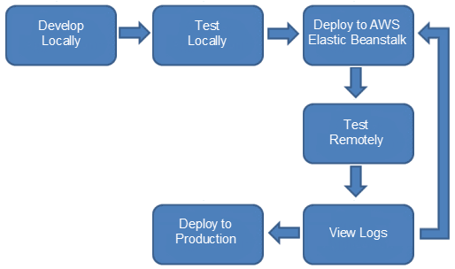

Download a sample application: [I am using a ubuntu linux machine to download the code]
wget https://codeload.github.com/awslabs/eb-node-express-signup/zip/master
mv master master.zip
We're going to make a few changes to the code, so go ahead and unzip the archive
unzip master.zip
cd eb-node-express-signup-master

Output:
ubuntu@ip-10-236-169-52:~/demo/eb-node-express-signup-master$ ls -l
total 48
-rw-rw-r-- 1 ubuntu ubuntu 80 Jan 2 17:05 app_config.json
-rw-rw-r-- 1 ubuntu ubuntu 227 Jan 2 17:05 iam_policy.json
-rw-rw-r-- 1 ubuntu ubuntu 11680 Jan 2 17:05 LICENSE.txt
-rw-rw-r-- 1 ubuntu ubuntu 93 Jan 2 17:05 NOTICE.txt
-rw-rw-r-- 1 ubuntu ubuntu 209 Jan 2 17:05 package.json
drwxrwxr-x 4 ubuntu ubuntu 4096 Jan 2 17:05 public
-rw-rw-r-- 1 ubuntu ubuntu 1673 Jan 2 17:05 README.md
drwxrwxr-x 2 ubuntu ubuntu 4096 Jan 2 17:05 routes
-rw-rw-r-- 1 ubuntu ubuntu 2899 Jan 2 17:05 server.js
drwxrwxr-x 2 ubuntu ubuntu 4096 Jan 2 17:05 views

In the top-level directory you'll see a file called app_config.json. Open this file in a text editor. As you can see, the file contains a JSON object with three name-value pairs. The value strings are currently empty
cat app_config.json
{
"AWS_REGION": "",
"STARTUP_SIGNUP_TABLE": "",
"NEW_SIGNUP_TOPIC": ""
}

We're going to use this JSON to tell our application which region to connect to and which DynamoDB
table and SNS topic to use. In order to do that, we first need to create the table and the topic.

Creating a DynamoDB Table
Let's create a DynamoDB table for our application.
- Sign in to the AWS Management Console and open the Amazon DynamoDB console at https://console.aws.amazon.com/dynamodb/.
- In the menu bar, in the region selector, click the region where you want to deploy your application. For this tutorial, let's use US East (N. Virginia).
- Click Create Table.
- In the Create Table wizard, in the Table Name box, type my-startup-signup-table.
- For the Primary Key Type, click Hash.
- Under Hash Attribute Name, click String. In the corresponding box, type email. Click Continue.
- We're not going to add any additional indexes, so on the Add Indexes page, click Continue.
- For our sample app, we can use the minimum provisioned throughput capacity for our table. Both the read and write capacity units should be set to "1" by default, and the Help me calculate how much throughput capacity I need to provision check box should be cleared. ClickContinue.
- Our app won't need any Throughput Alarms, so clear the Use Basic Alarms check box and then click Continue.
- On the Review page, take a look at the table specifications. The values should look something like this:

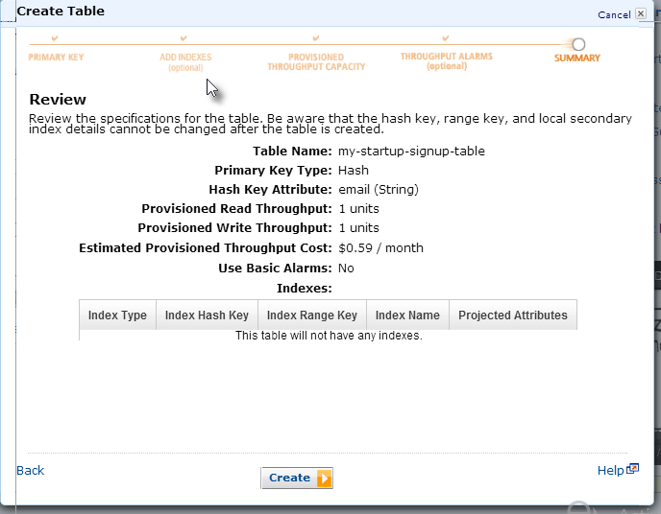
If everything looks correct, click Create.
DynamoDB will start the table creation process. When the process is complete, the table status will be listed as ACTIVE.
- Now that we have a database table, we can add the table name to the configuration file for the app. If you haven't done so already, open the application folder and open app_config.json in a text editor. The value for "STARTUP_SIGNUP_TABLE" is an empty string. Let's insert the name of the new database. The name-value pair should look like this:
"STARTUP_SIGNUP_TABLE": "my-startup-signup-table",
You can leave the file open, but be sure to save your edits.
You've created the DynamoDB table. Now let's create the SNS topic

Creating an SNS Topic
Our app is designed to notify the site owner of each new signup. When the data from the signup form is successfully written to the DynamoDB table, the app sends an SNS notification. To make this work, we need to create an SNS topic.
- Sign in to the AWS Management Console and open the Amazon SNS console at https://console.aws.amazon.com/sns/.
- We'll use the same region for SNS as we did for DynamoDB. Ensure that US East (N. Virginia) is still selected in the region selector, and then click Create New Topic.
- In the Create New Topic dialog box, enter my-sns-topic. We can leave the Display Name blank. Click Create Topic.
- Now we need to create a subscription that tells SNS how and where to send the notification. Click Create Subscription.
- In the Create Subscription dialog box, select Email as the protocol. In the Endpoint box, type the email address that will receive the notification. (For this tutorial, you'll probably want to send the notification to your own email account, as you'll need to respond to a confirmation message.) Click Subscribe. In the confirmation message that appears, click Close.
- The email address you provided should receive a message titled "AWS Notification — Subscription Confirmation." It may take a moment for the email to appear. Open the message and click Confirm subscription.
- Now that we've created an SNS topic, we can plug the Topic ARN into our config file, so that the application knows where to send notifications. An ARN, or Amazon Resource Name, is a unique identifier for an AWS resource. We can get the Topic ARN from the SNS Management Console.
Topic arn : arn:aws:sns:us-east-1:766670000560:jpanotification
Copy the Topic ARN and paste it into app_config.json, in the empty value corresponding to "NEW_SIGNUP_TOPIC". The name-value pair should look like this (but with your particular topic ARN):
"NEW_SIGNUP_TOPIC": "arn:aws:sns:us-East-2:123456789012:my-sns-topic"
While you're at it, set the region to "us-east-1". The final app_config file should look like this, but with your specific value for the signup topic ARN:
{
"AWS_REGION": "",
"STARTUP_SIGNUP_TABLE": "my-startup-signup-table",
"NEW_SIGNUP_TOPIC": "arn:aws:sns:us-east-1:7660000273560:jpanotification"
}

When you're finished updating the config file, save and close it. That's it for the SNS topic. Now let's use Elastic Beanstalk to roll out the app.

Deploying with Elastic Beanstalk
We've downloaded the source code and set the configuration values. Now, let's deploy the app with Elastic Beanstalk.
Elastic Beanstalk requires that your application be bundled as a .zip or .war file. But — and this is key —you have to compress the application files directly, rather than compressing the directory that contains them.
We already extracted the files from the sample app archive, so we'll need to compress them again. To do so, open the app folder (eb-node-express-signup-master), select all the items in the folder, and compress them.
zip -r web_deploy.zip *

or
jar -cvf mywebapp.war *

Elastic Beanstalk

- Sign in to the AWS Management Console and open the AWS Elastic Beanstalk console at https://console.aws.amazon.com/elasticbeanstalk/.
- Ensure that US East (N. Virginia) is still selected in the region selector, and click Create a New Application. [Top right corner]
- Under Application Information, type a name for the application, and, if you'd like, a description. For this tutorial, let's call the application my-startup-app. When you're finished, click Create.
- On the Environment Type page, In the Predefined configuration box, click Node.js. You shouldn't need to change any other settings. Your environment settings should look like this:

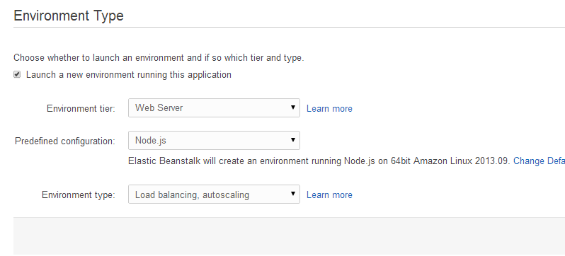
Click Continue.
- On the Application Version page, select Upload your own and select the compressed application file that you created. Click Continue
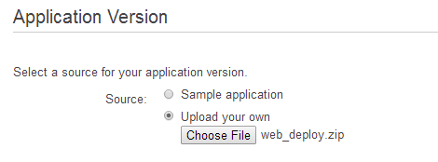
- On the Environment Information page, leave the settings as they are and click Continue.
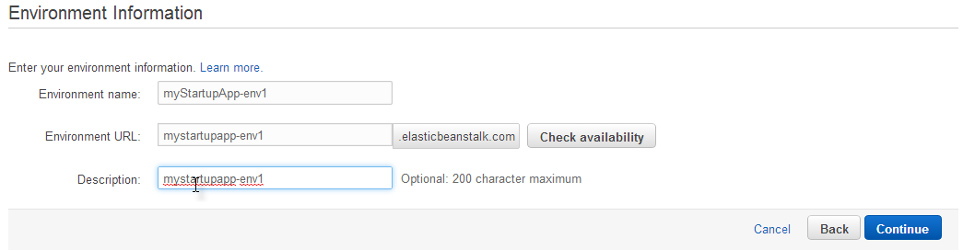
- On the Additional Resources page, ensure that both check boxes are cleared, and then click Continue.
- The Configuration Details page presents a number of options, but for this tutorial we need to be aware of only one.
Set the Instance profile box to aws-elasticbeanstalk-ec2-role. This is the default instance profile for the application. An instance profile is a container for an IAM role. You can use IAM to attach a policy to this instance profile. IAM policies grant permission to perform certain actions. In this case, we want an IAM policy that lets our app publish Amazon SNS notifications and put items to DynamoDB. Let's create that policy.
  - Leave the Configuration Details page as-is for now. We'll be back to it shortly. In the Services menu, find IAM and open it in a new browser window. In the IAM console, under Dashboard, click Roles.
  - Select the check box next to aws-elasticbeanstalk-ec2-role. In the details pane, click Attach Role Policy.
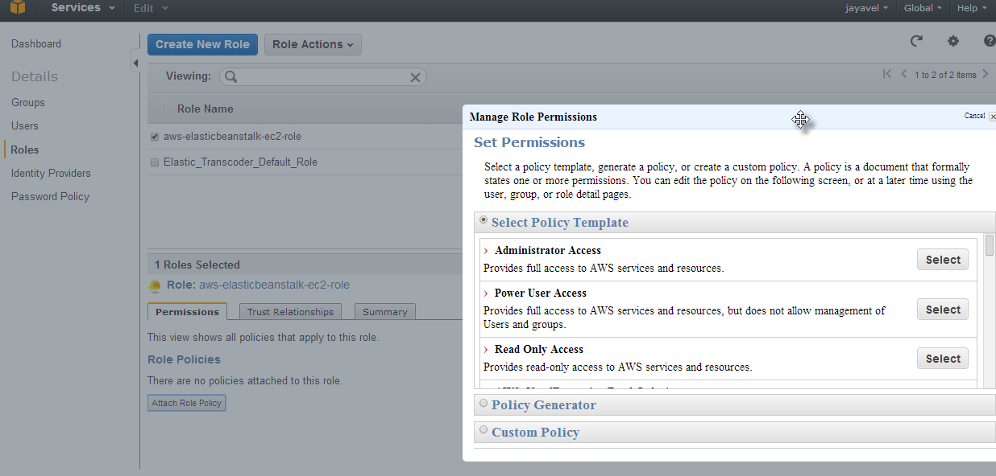
  - In the Manage Role Permissions dialog box, click Custom Policy, and then click Select.
  - Under Set Permissions, in the Policy Name field, type my-startup-policy.
In the eb-node-express-signup-master directory (the downloaded, uncompressed archive), open iam_policy.json and copy its contents. Paste the contents into the Policy Document box of the Manage Role Permissions dialog box.
{
"Statement": [
{
"Effect": "Allow",
"Action": [ "dynamodb:PutItem" ],
"Resource": [ "*" ]
},
{
"Effect": "Allow",
"Action": [ "sns:Publish" ],
"Resource": [ "*" ]
}
]
}
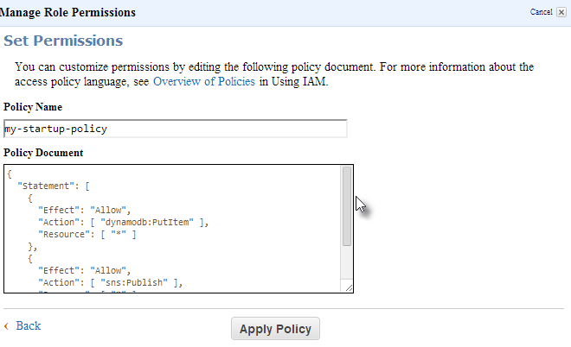

- Close the IAM console and go back to the Elastic Beanstalk console. On the Configuration Details page, click Continue.
- On the Review page, verify that all the settings are as you want them, and then click Create. On the AWS Elastic Beanstalk Dashboard, you can watch in real time as Elastic Beanstalk creates an environment and deploys the app. The process will take a few minutes. When the deployment is finished and the environment health is listed as "Green", click the URL of the app.
- You should see the deployed sample application. You can test it by filling out the signup form and verifying that you receive a notification.
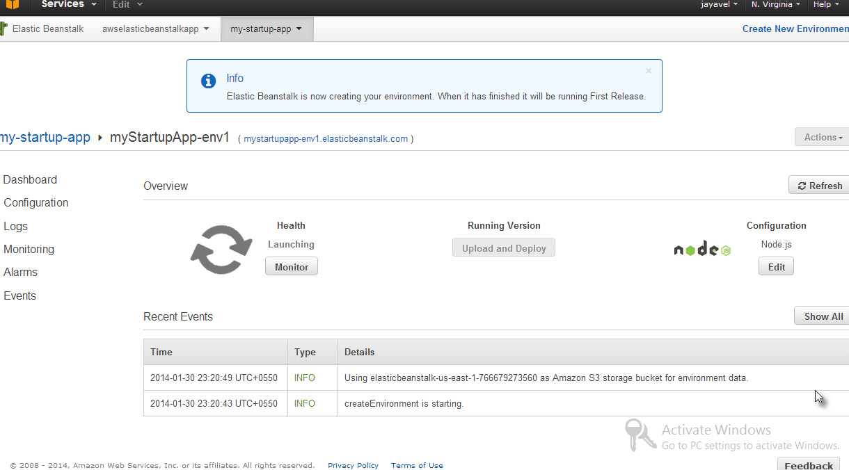

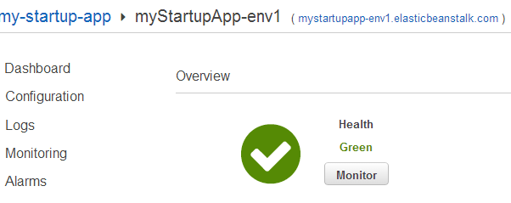

Recent Events
2014-01-30 23:26:37 UTC+0550 | INFO | Successfully launched environment: myStartupApp-env1
2014-01-30 23:26:36 UTC+0550 | INFO | Application available at mystartupapp-env1.elasticbeanstalk.com.
2014-01-30 23:26:17 UTC+0550 | INFO | Adding instance 'i-c6da4de8' to your environment.
2014-01-30 23:25:35 UTC+0550 | INFO | Added EC2 instance 'i-c6da4de8' to Auto Scaling Group 'awseb-e-wwjuqnsnxq-stack-AWSEBAutoScalingGroup-1OAQLIZO1WNPV'.
2014-01-30 23:23:04 UTC+0550 | INFO | Created CloudWatch alarm named: awseb-e-wwjuqnsnxq-stack-AWSEBCloudwatchAlarmHigh-1RB2VMJ0GBYJQ
2014-01-30 23:23:04 UTC+0550 | INFO | Created CloudWatch alarm named: awseb-e-wwjuqnsnxq-stack-AWSEBCloudwatchAlarmLow-1E290YZ27TDHI
2014-01-30 23:23:01 UTC+0550 | INFO | Created Auto Scaling group policy named: arn:aws:autoscaling:us-east-1:766679273560:scalingPolicy:e65499b8-c788-4b0f-a761-ad36e19ecbf1:autoScalingGroupName/awseb-e-wwjuqnsnxq-stack-AWSEBAutoScalingGroup-1OAQLIZO1WNPV:policyName/awseb-e-wwjuqnsnxq-stack-AWSEBAutoScalingScaleUpPolicy-1JNLEQTX06B63
2014-01-30 23:23:01 UTC+0550 | INFO | Created Auto Scaling group policy named: arn:aws:autoscaling:us-east-1:766679273560:scalingPolicy:284d3c43-dfe0-47c8-ba64-dd8c4040f4c5:autoScalingGroupName/awseb-e-wwjuqnsnxq-stack-AWSEBAutoScalingGroup-1OAQLIZO1WNPV:policyName/awseb-e-wwjuqnsnxq-stack-AWSEBAutoScalingScaleDownPolicy-GFILQCIEDSQ2
2014-01-30 23:22:57 UTC+0550 | INFO | Created Auto Scaling group named: awseb-e-wwjuqnsnxq-stack-AWSEBAutoScalingGroup-1OAQLIZO1WNPV
2014-01-30 23:22:57 UTC+0550 | INFO | Waiting for EC2 instances to launch. This may take a few minutes.
2014-01-30 23:21:34 UTC+0550 | INFO | Created Auto Scaling launch configuration named: awseb-e-wwjuqnsnxq-stack-AWSEBAutoScalingLaunchConfiguration-17GZ71J2JIXC5
2014-01-30 23:21:30 UTC+0550 | INFO | Created security group named: awseb-e-wwjuqnsnxq-stack-AWSEBSecurityGroup-1AD9AD3BNR2D4
2014-01-30 23:21:10 UTC+0550 | INFO | Created load balancer named: awseb-e-w-AWSEBLoa-KKFCVB8SLNF5
2014-01-30 23:20:49 UTC+0550 | INFO | Using elasticbeanstalk-us-east-1-766679273560 as Amazon S3 storage bucket for environment data.
2014-01-30 23:20:43 UTC+0550 | INFO | createEnvironment is starting.

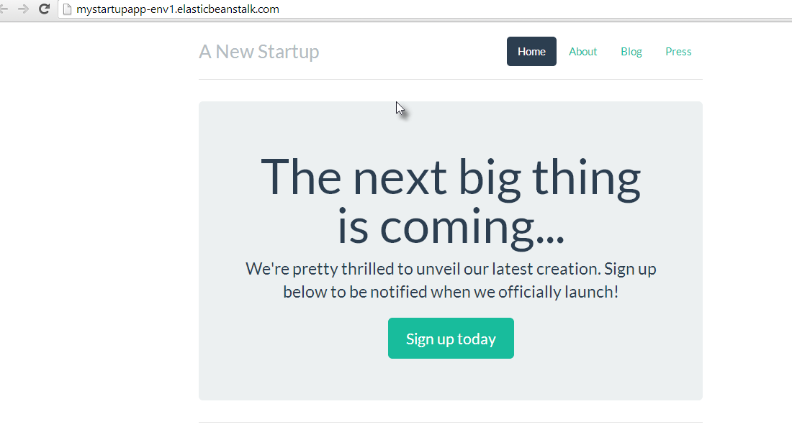
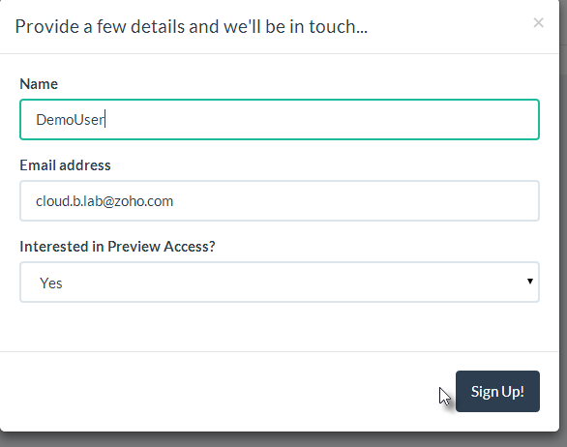

Changing an Environment Variable
Now that our application is deployed, let's try setting an environment variable. You can access Node.js environment variables usingprocess.env.ENVVAR, where ENVVAR is an environment variable used by the app. You can set the value of ENVVAR in the Elastic Beanstalk console. Let's see how it works.
Our application's server.js file contains the following line of code:
app.locals.theme = process.env.THEME;

This makes the THEME environment variable available to the application. We use this variable in one of our views, layout.jade.
- var setTheme = theme
if setTheme
link(href="../static/bootstrap/css/theme/" + setTheme + "/bootstrap.css", rel="stylesheet")
else
link(href="../static/bootstrap/css/theme/flatly/bootstrap.css", rel="stylesheet")
The theme variable changes the CSS that's applied to our app. By default, the flatly theme is used. But we can pass in other themes: amelia,default, slate, and united. To see how this works, explore public/static/bootstrap/css/ in the archive.
Okay, let's try changing a variable on our deployed app.
- In the Elastic Beanstalk console, in the navigation pane for your environment, click Configuration.
- Open Software Configuration and scroll down to the table of Environment Properties. At the bottom of the table, add the name THEME and the value slate.
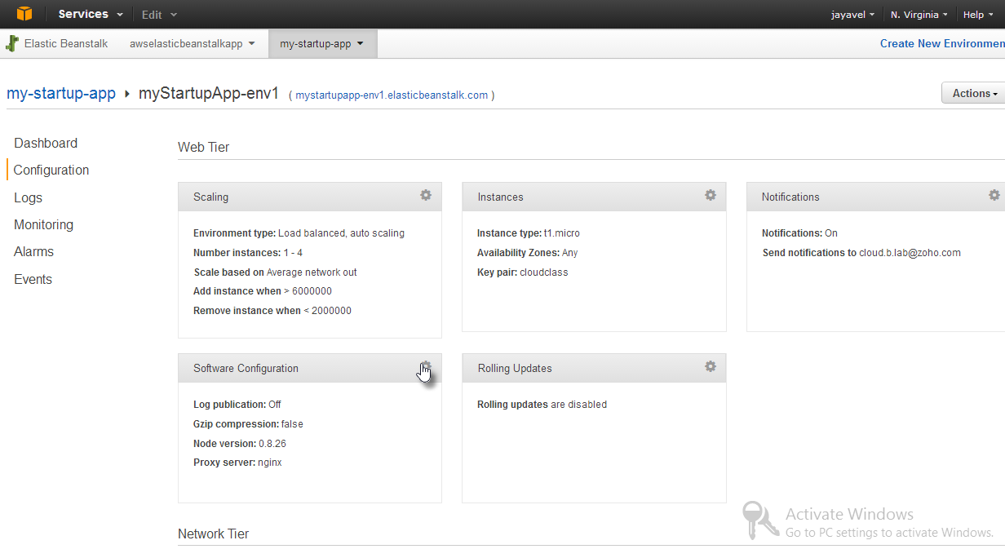
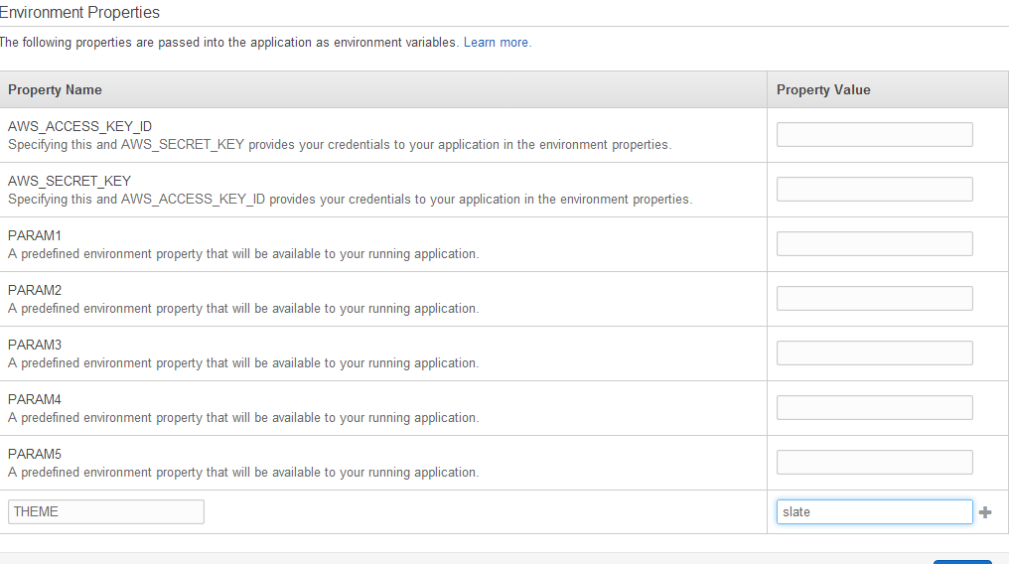
- Click Save.
- When the environment is done updating, click the URL for the app. We have a brand new look!
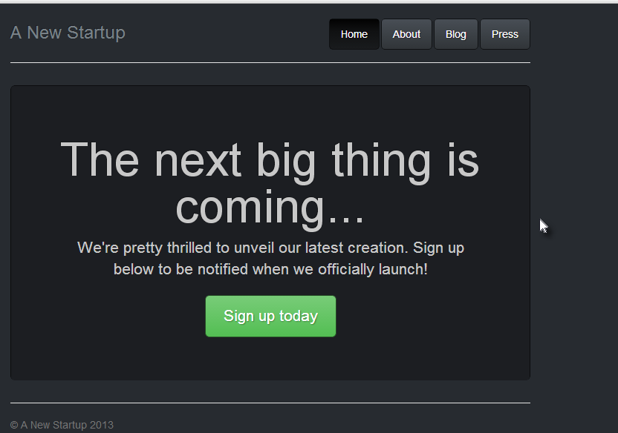

Troubleshooting with Logs
What if there's a problem? Say you followed all of the steps above, and you clicked the URL, and ... no app. With our sample app, which runs on an nginx server, a deployment problem is likely to result in a "502 Bad Gateway" message. The "502" message is not very informational. To troubleshoot a deployment issue, you may need to use the logs that are provided by AWS Elastic Beanstalk.
For example, let's say that, in the process of updating app_config.json, you accidentally leave off a quotation mark. Then, when you finish the deployment, you see the 502 error. How do you determine what happened, and how do you fix the problem? Let's check the logs.
- In the Elastic Beanstalk console, in the navigation pane for your environment, click Logs.
- At the Logs page, click Snapshot Logs. Wait for your environment to update, and then click View log file. In the log file, you can see just what happened on the server side during deployment and runtime. There's a lot of material to sort through, and we're not going to cover the different sections of the log in this tutorial. But if you did indeed leave out a quotation mark in the config file and you scrolled through the log to /var/log/nodejs/nodejs.log, you'd find an error similar to this:
- SyntaxError: Unexpected token u
- at Object.parse (native)
- at Object.<anonymous> (/var/app/current/server.js:23:15)
- at Module._compile (module.js:449:26)
- at Object.Module._extensions..js (module.js:467:10)
- at Module.load (module.js:356:32)
- at Function.Module._load (module.js:312:12)
- at Module.runMain (module.js:492:10)
- at process.startup.processNextTick.process._tickCallback (node.js:245:9)

- undefined:2
- "AWS_REGION": us-west-2",
^
In this case, the "Unexpected token u" message appears because the parser expected a quotation mark instead of a "u" in the string us-west-2". Now that we've found the problem, we can fix it.
- If you were actually troubleshooting this issue, you'd go back to the application code in your local environment and fix the missing quotation mark. Then you'd need to create a new .zip archive to upload.
- To redeploy the app, go to Dashboard, click Upload and Deploy, and choose your updated .zip file.
- If necessary, change the version label to something new. For example, if your first deployment was labeled "Archive", you can label this second deployment "Archive-2" or something like that.
- Click Deploy. Elastic Beanstalk will update the environment.
- When the environment is updated and listed as "Green", go to the app URL and test your app.
Of course, you'd normally try to catch a config error in development. But if an error does get through to production or you just want to update your app, Elastic Beanstalk makes it fast and easy to redeploy.

